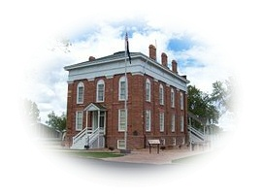
Fillmore City Fillmore City Cemetery
“Silent City”

75 West Center Street
Fillmore, Utah 84631
Utah’s First Capital (435) 743-5233

PERMISSION TO BURY

Fillmore City Cemetery:
I give permission for ______________________________________________to be buried in block_________, lot_____, grave _________ on (date of burial) _________________, 20_____.

Print name: __________________________________ (owner of burial rights)
Signed: __________________________________________ Date:__________________________
Address:__________________________________________ Phone: ________________________
City & State: _______________________________________

State of _______________________
County of ______________________
Subscribed and sworn to before me this _______________________, 20____ (date)
Personally appeared before me __________________________________________
(owner of burial rights)

(Seal)
___________________________________
Notary Public

